Benin

## Freedom House political status

The data set shows the Freedom House political scores and status of the country each year.

## # A tibble: 19 x 5  
## country iso3c date mean status  
## <chr> <chr> <dbl> <dbl> <chr>   
## 1 Benin BEN 1996 2 Free   
## 2 Benin BEN 1998 2 Free   
## 3 Benin BEN 2000 2 Free   
## 4 Benin BEN 2002 2.5 Free   
## 5 Benin BEN 2003 2 Free   
## 6 Benin BEN 2004 2 Free   
## 7 Benin BEN 2005 2 Free   
## 8 Benin BEN 2006 2 Free   
## 9 Benin BEN 2007 2 Free   
## 10 Benin BEN 2008 2 Free   
## 11 Benin BEN 2009 2 Free   
## 12 Benin BEN 2010 2 Free   
## 13 Benin BEN 2011 2 Free   
## 14 Benin BEN 2012 2 Free   
## 15 Benin BEN 2013 2 Free   
## 16 Benin BEN 2014 2 Free   
## 17 Benin BEN 2015 2 Free   
## 18 Benin BEN 2016 2 Free   
## 19 Benin BEN 2017 2 Free

## Freedom House classification of political change

The data set shows the GDP growth and the ecomic growth classification of the country each year.

## # A tibble: 19 x 4  
## country iso3c date politicalChangeFH  
## <chr> <chr> <dbl> <chr>   
## 1 Benin BEN 1996 no change   
## 2 Benin BEN 1998 no change   
## 3 Benin BEN 2000 democratization   
## 4 Benin BEN 2002 no change   
## 5 Benin BEN 2003 democratization   
## 6 Benin BEN 2004 no change   
## 7 Benin BEN 2005 no change   
## 8 Benin BEN 2006 no change   
## 9 Benin BEN 2007 no change   
## 10 Benin BEN 2008 no change   
## 11 Benin BEN 2009 no change   
## 12 Benin BEN 2010 no change   
## 13 Benin BEN 2011 no change   
## 14 Benin BEN 2012 no change   
## 15 Benin BEN 2013 no change   
## 16 Benin BEN 2014 no change   
## 17 Benin BEN 2015 no change   
## 18 Benin BEN 2016 no change   
## 19 Benin BEN 2017 no change

## Freedom House score trend

The plot shows the Freedom House scores trend of the country.

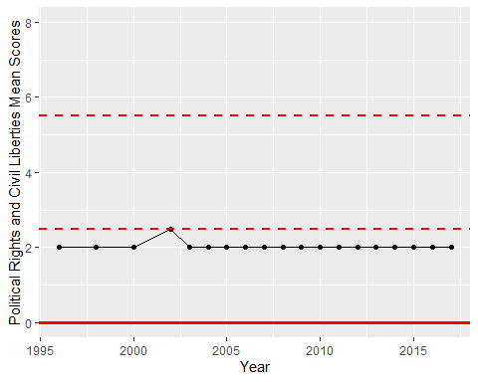

Freedom House Score Trend